**Twitter Assignment - FALL 2021**

TEAM - 5THEPEOPLE

25 September 2021

DataScience Cohort Members -

1. Aryan Jadon
2. Swathi Anandram
3. Harika Nalam
4. Shreya Nimbhorkar

Cloud Cohort Members-

1. Supreetha M A

# Code Base and Repository

**Technologies Used -**

**Backend - Python Django Framework**

**Frontend - HTML, CSS and javascript**

Code base and repository link can be found at -<https://github.com/aryan-jadon/twitter-assignment-2021>

libraries versions used for this project can be found at- <https://github.com/aryan-jadon/twitter-assignment-2021/blob/main/requirements.txt>

Instructions for how to run the project is written in a readme.md file - <https://github.com/aryan-jadon/twitter-assignment-2021/blob/main/README.md>

**Code base Responsibilities -**

Aryan Jadon - Backend

Harika and Shreya - Testing

Supreetha and Swathi - Fronend

All project files have author names in it.

Screenshots of the project are added in the project repo

# UI Interactions with Screenshots

All Screenshots can be found at - <https://github.com/aryan-jadon/twitter-assignment-2021/tree/main/screenshots>

***Index Page*** 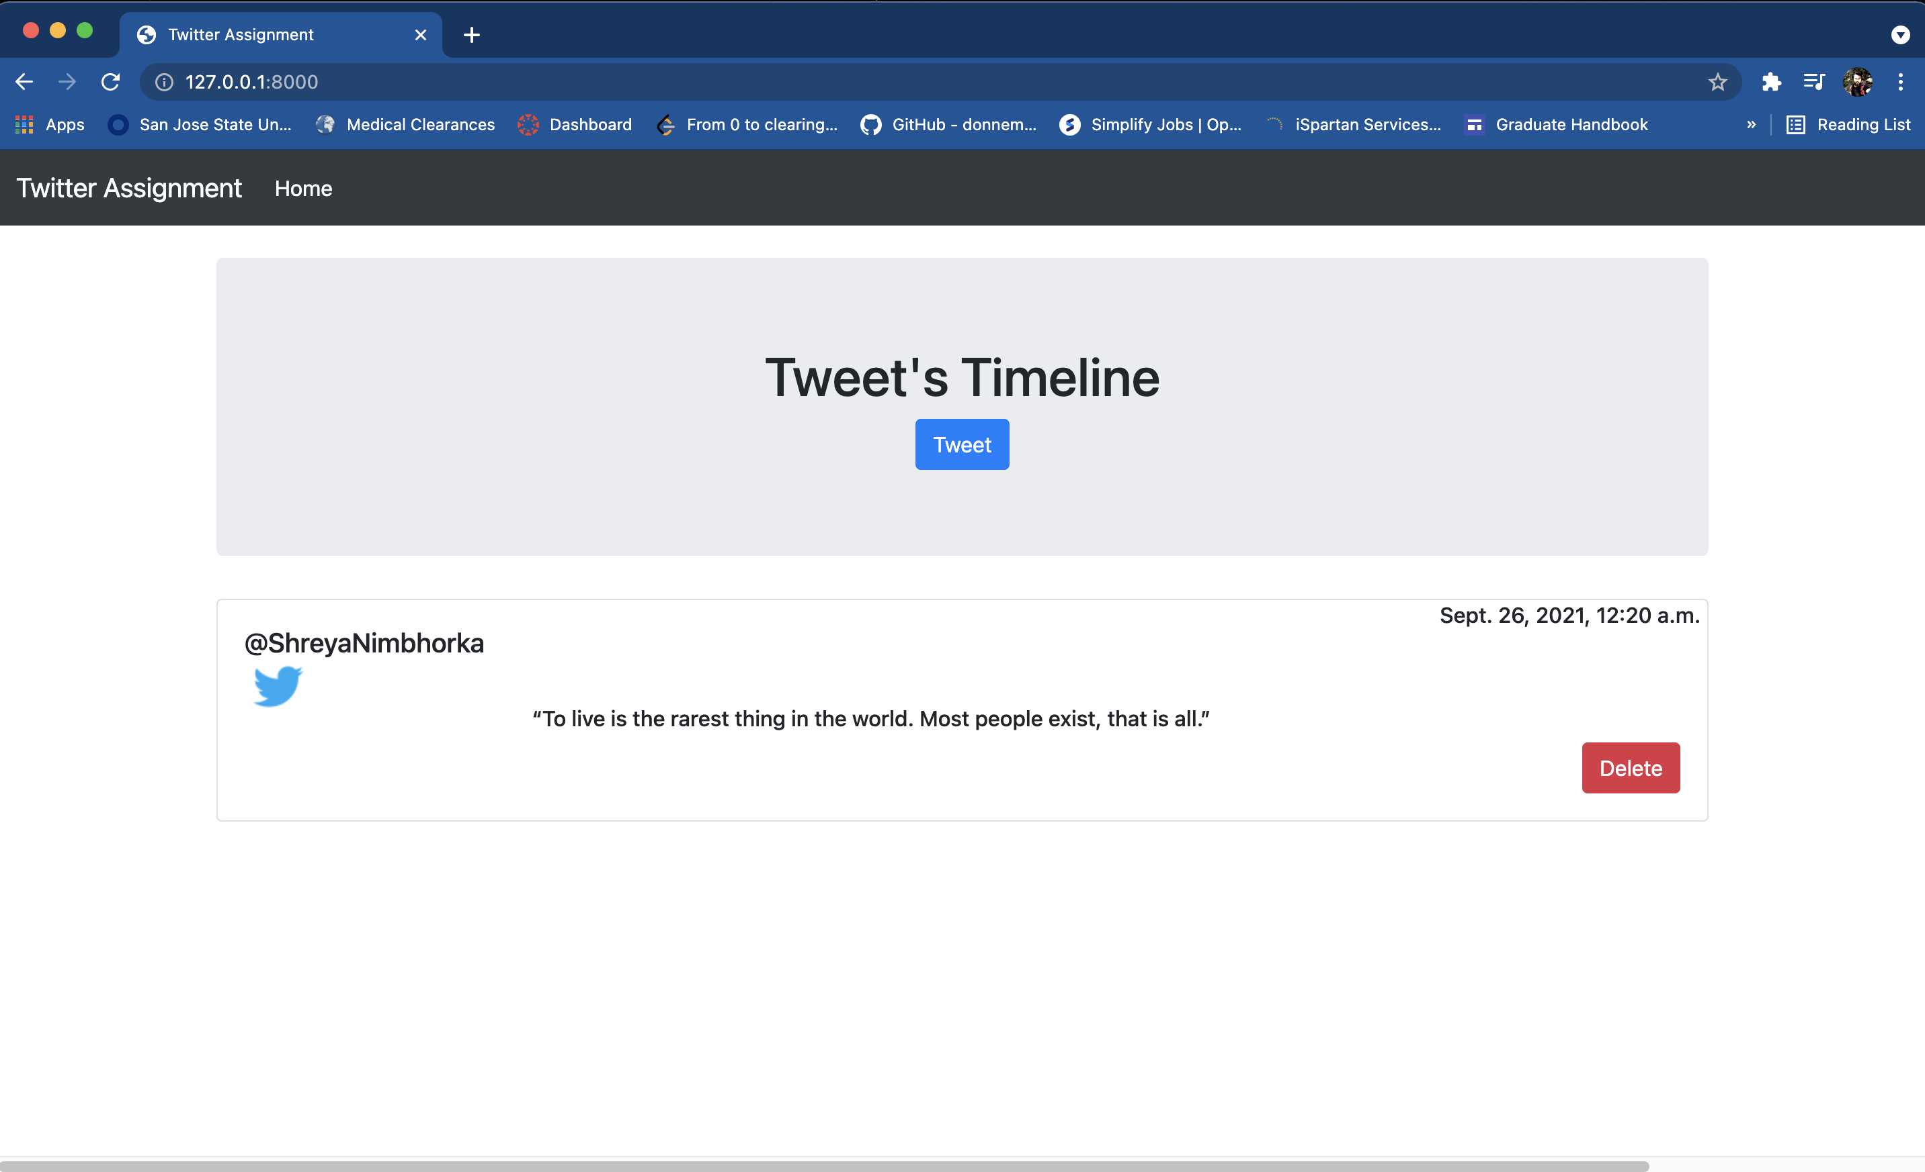

**Figure 1.** Index page showing all the tweets of a user

Index Page retrieves all the tweets of the logged in user using twitter api credentials and display the twitter user name, tweet date along with the tweet with the option of deleting the user tweet.

***Create Tweet Page***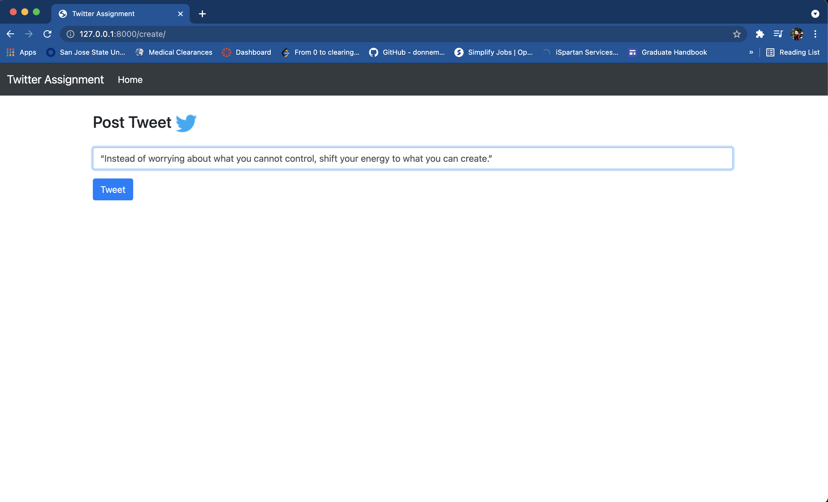

**Figure 2:** Create Tweet Form Page

Create Tweet Page shows the tweet form to the user, user cannot post the empty text.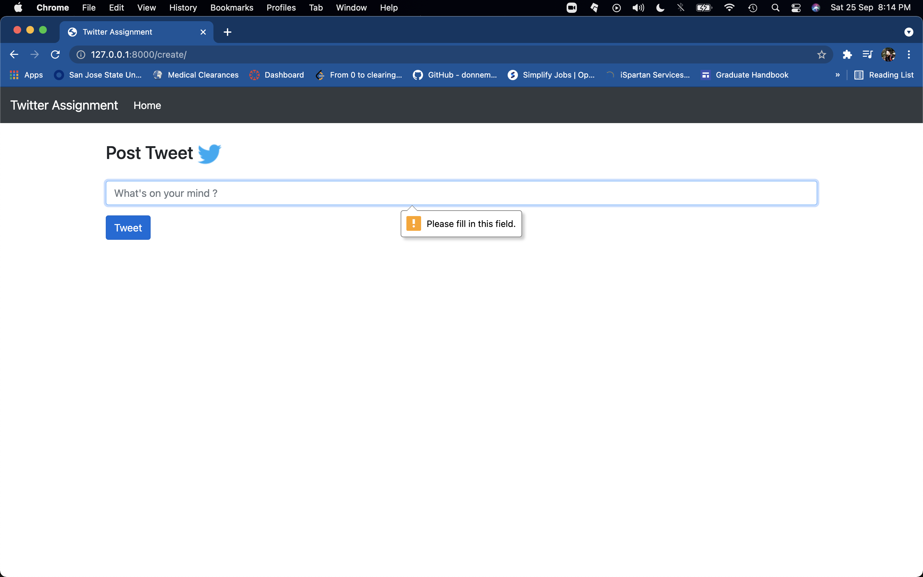

***Create Tweet Request*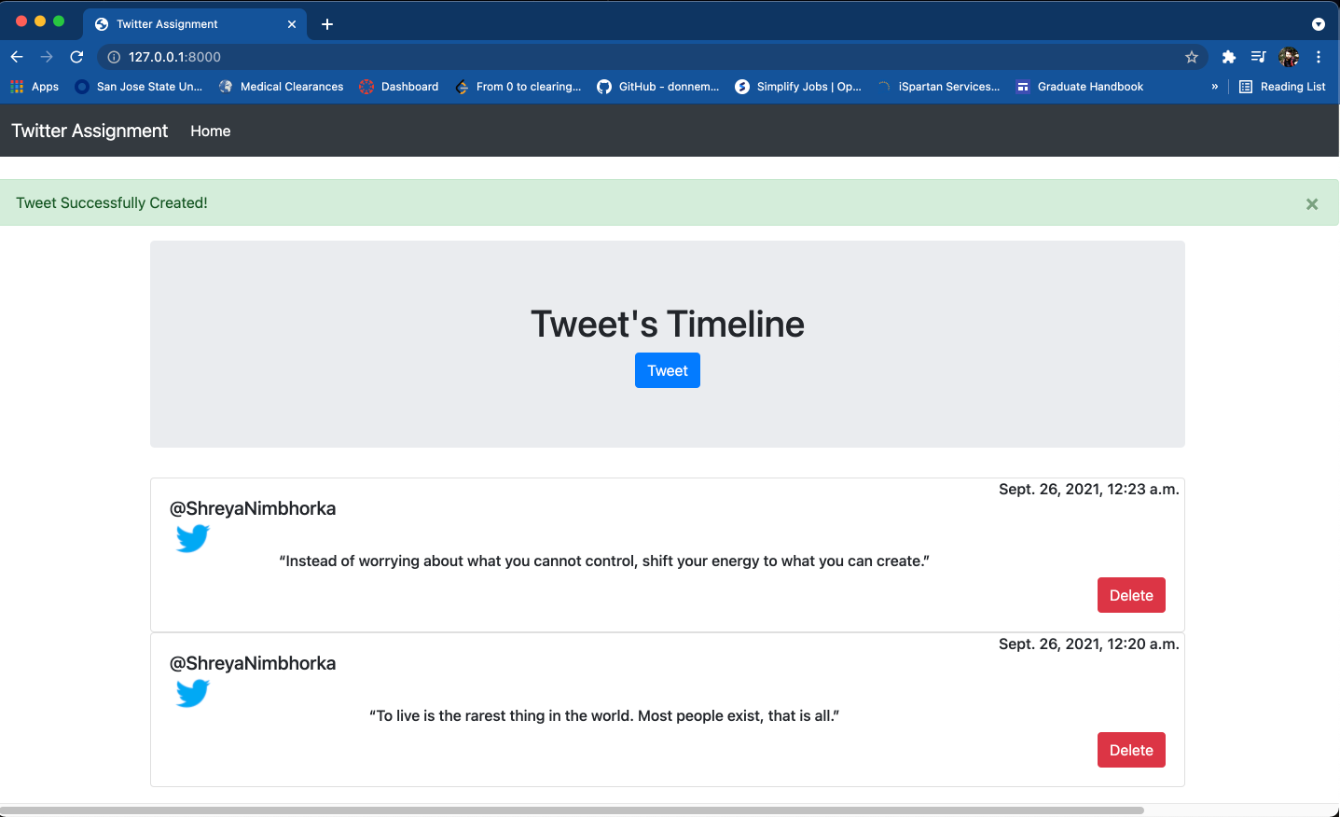**

**Figure 3:** Index page showing the newly added tweet with the success prompt.

***Delete Tweet Request*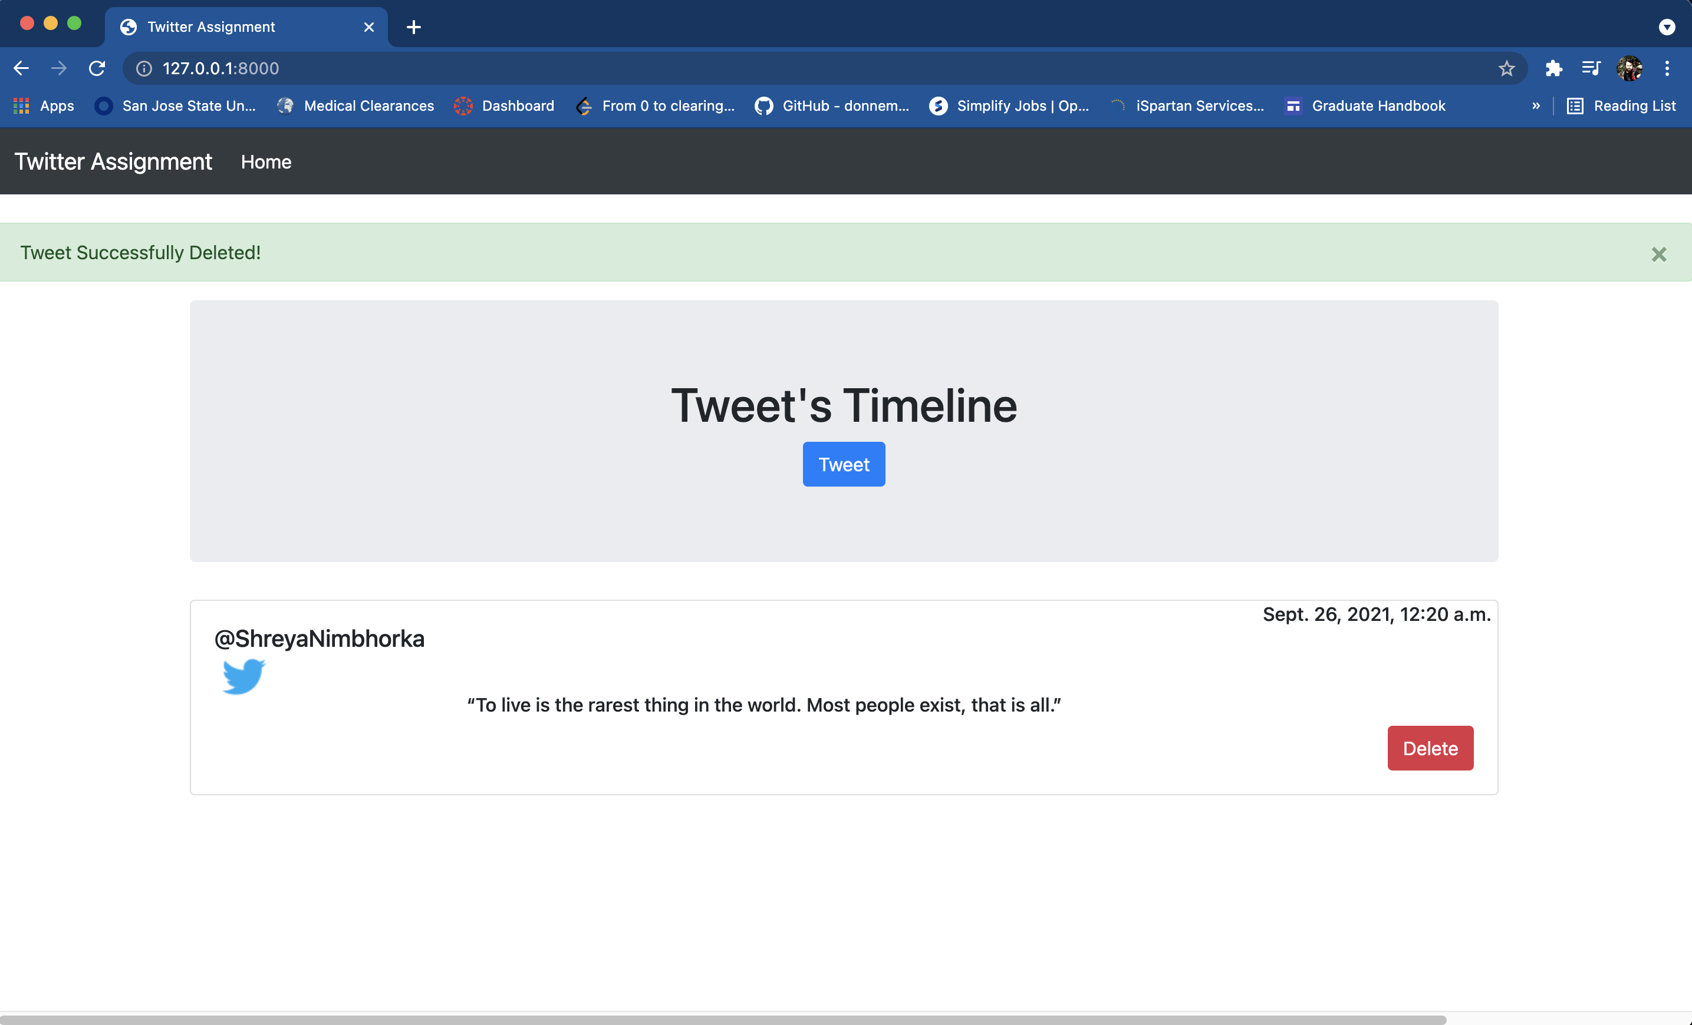**

**Figure 4:** Index Page showing the updated tweet timeline with the deleted tweet

***Duplicate Tweet***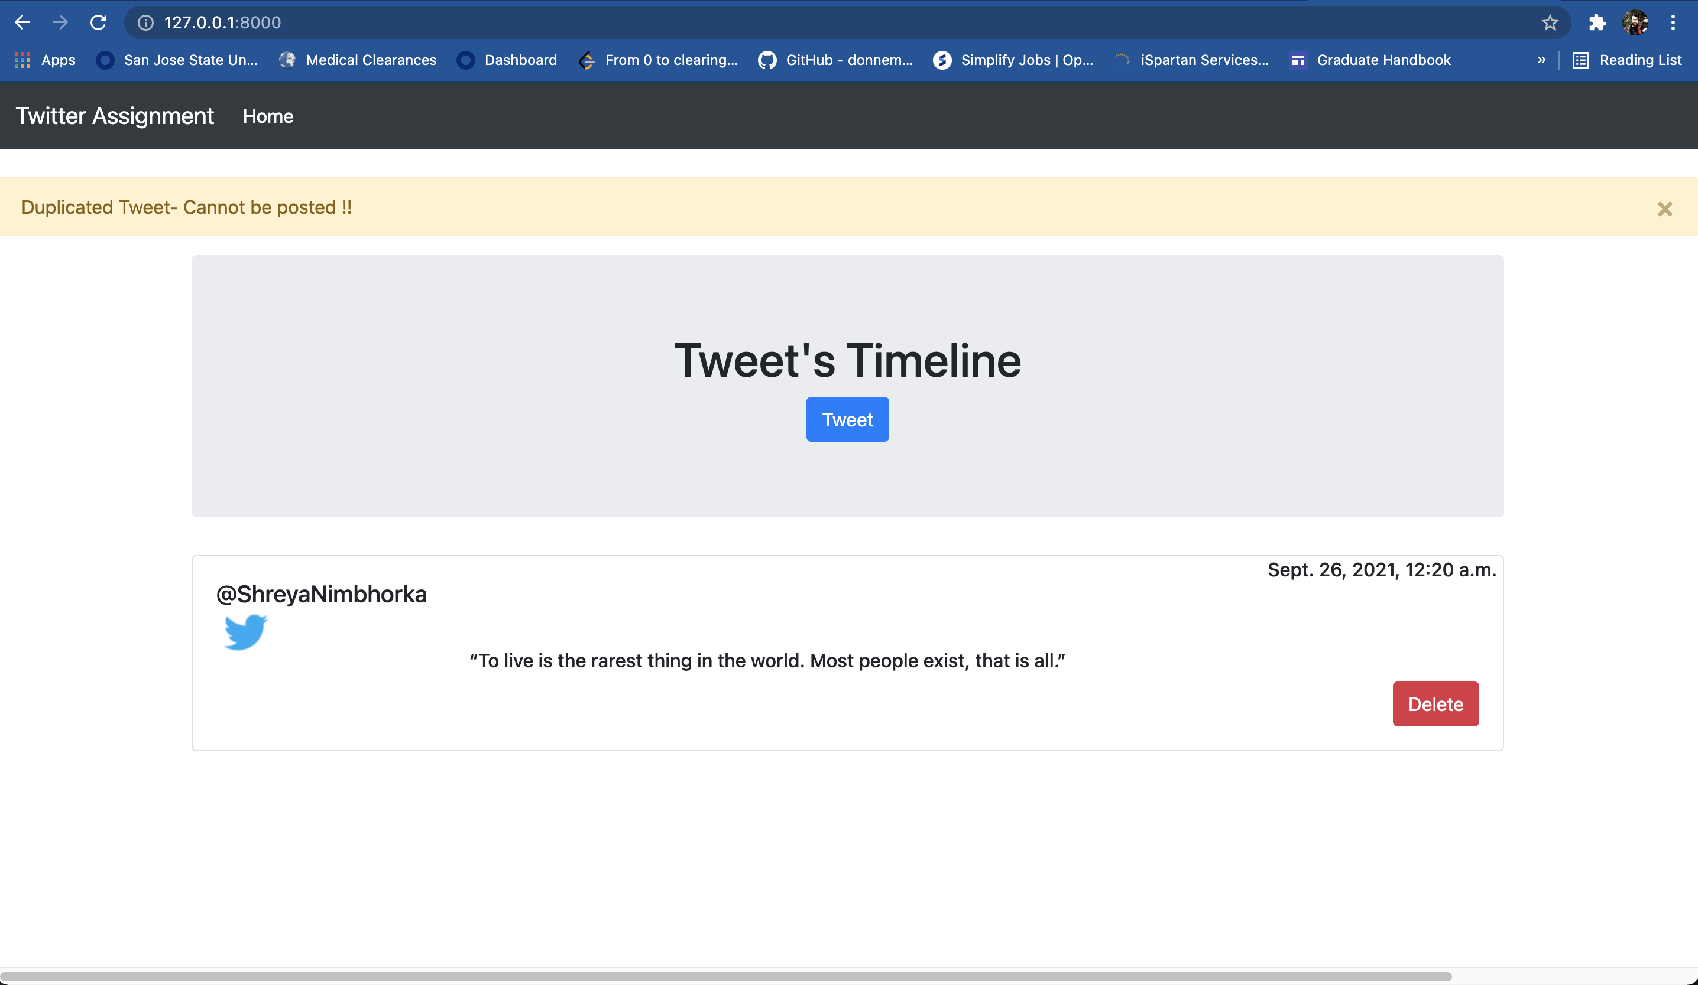

**Figure 5:** Index Page Showing the duplicated tweet message, users are not allowed with the duplicated tweet

***Test Cases***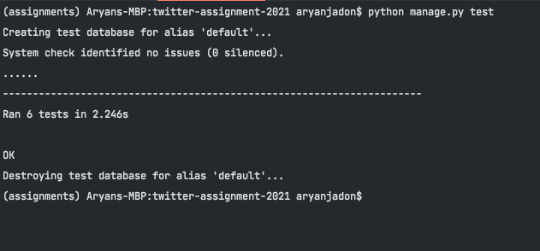

**Figure 6:** Project Terminal Showing all the test cases are passed

Detailed Test Logic functions can be found here **-** *https://github.com/aryan-jadon/twitter-assignment-2021/blob/main/twitter_services/tests.py*